# Introduction to Inheritance:

* Inheritance is a part of object-oriented programming and reusability is a very important feature of OOPS.

* The concept of Reusability in C++ is supported using Inheritance.

* Inheritance helps you reuse any code which you have written in classes.

* Repetition of code is bad practice while coding, whenever you're writing any code that you have already written then you're violating DRY (Don't Repeat Yourself) principle of coding.

* Reusing classes saves time and money.

* Reusing already tested and debugged class will save a lot of effort of developing and debugging the same thing again.

* We can reuse the properties of an existing class by inheriting from it.

_ _ _ _ _ _ _ _ _ _ _ _ _ _ _ _ _ _ _ _ _ _ _ _ _ _ _

# Some Common Terminologies in Inheritance:

* The existing class is called as the "Base Class" or "Parent Class".

* The new class which is inheriting the "Parent Class" is called as the "Derived Class" or "Child Class".

_ _ _ _ _ _ _ _ _ _ _ _ _ _ _ _ _ _ _ _ _ _ _ _ _ _ _

* TYPES OF INHERITANCE --->

# Types of Inheritance:

(i) Single Inheritance:

---> A derived class with only one Base Class

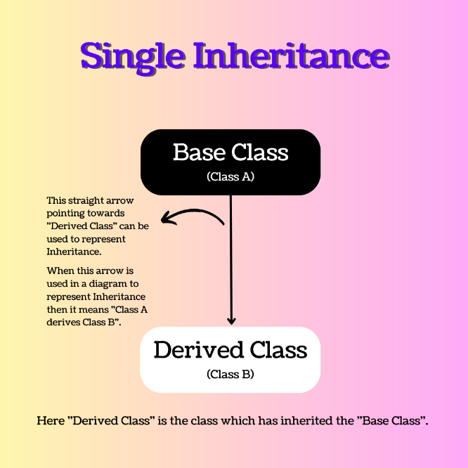 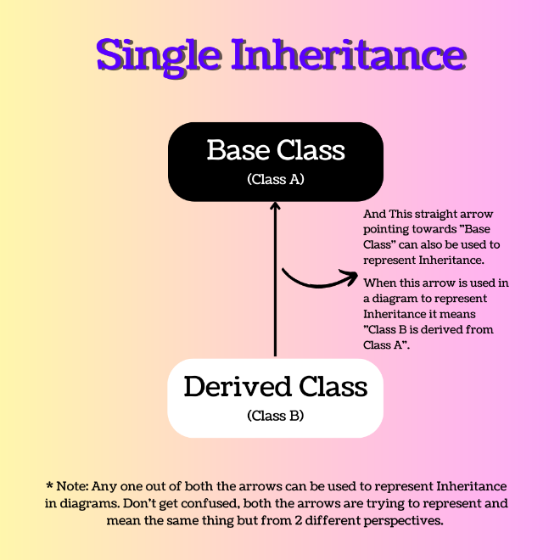

(ii) Multiple Inheritance

---> A derived class with more than one Base Class

(iii) Hierarchical Inheritance

---> Several Derived classes from a single Base Class

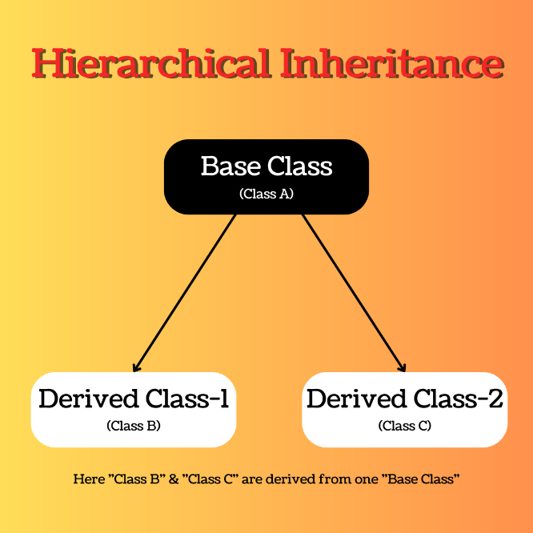 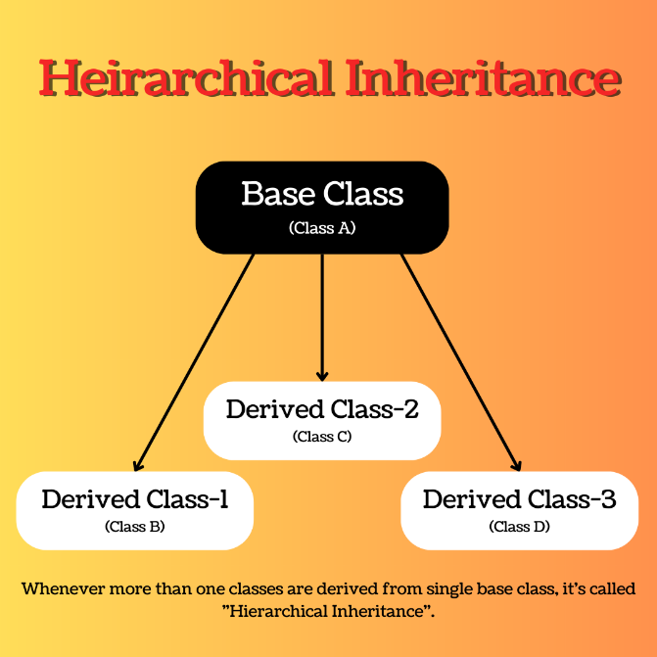

(iv) Multilevel Inheritance

---> Deriving a class from an already Derived Class

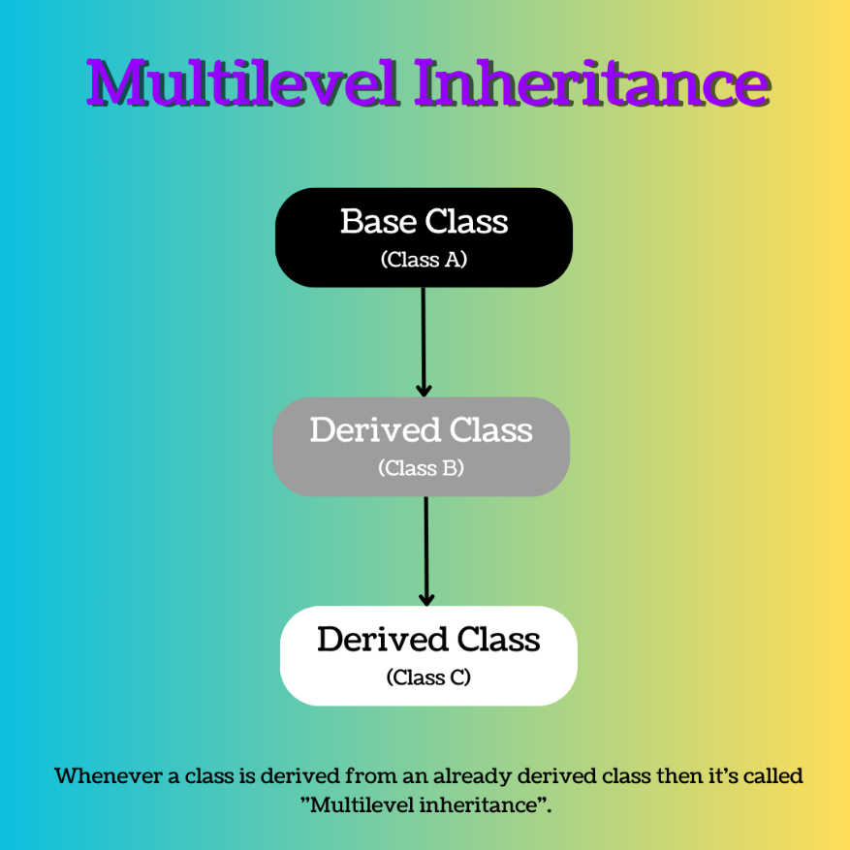

(v) Hybrid Inheritance

---> The process of combining more than one type of Inheritance together while deriving subclasses in a program is called a Hybrid Inheritance.

_ _ _ _ _ _ _ _ _ _ _ _ _ _ _ _ _ _ _ _ _ _ _ _ _ _ _